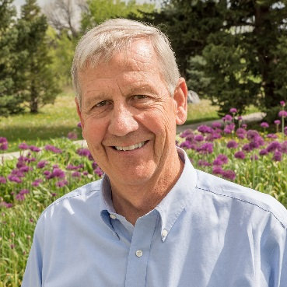
Chris possesses a diverse background in public and private planning. A founding partner of RRC Associates, he specializes in practical applications of research techniques including survey and qualitative research, modeling and applied analysis to solve problems in tourism and recreation, city planning, administration, and business applications. Parks needs assessments are particular areas of specialization. Chris has overseen numerous community/citizen surveys in towns and counties throughout the United States which provide input to resorts, parks, recreation, trails, open space, and planning needs assessments. The results of these studies typically become incorporated into master plans and other strategic or policy-oriented documents and are used to guide decision-making in a variety of settings.

Professional Experience
RELEVANT BOARD EXPERIENCE
(Former) Breckenridge Outdoor Education Center, Breckenridge, CO – boec.org

GP RED – Research, Education and Development for Health, Recreation and Land Management – gpred.org
(currently board president)

1983 to present MANAGING DIRECTOR/FOUNDING PARTNER
RRC Associates, Boulder, CO

Representative Projects

Tourism and Ski Area Visitor Research
Grand County/Winter Park
Town of Vail
Snowmass, CO
Estes Park, CO
Aspen, CO
Breckenridge, CO
Sun Valley, ID
Park City, UT

Housing and Transportation Surveys / Needs Assessments
Lakewood, CO Jefferson County, CO
San Miguel County, CO Roaring Fork Valley, CO
Gunnison County Keystone Resort, CO
Eagle County, CO Summit County, CO
Grand County, CO Mammoth Lakes, CA

Community / Master Planning: Examples include Glenwood Springs Telluride, Vail, Crested Butte, Breckenridge/Summit County, Rio Grande County, Aurora, CO; Girdwood AK, Douglas County, NV

Parks and Recreation Surveys/ Needs Assessments: Colorado examples include: Larimer County, Lafayette, Silverthorne, Westminster, Vail Recreation District, Superior, Jefferson County, CO, Grand Junction, Ken Caryl Ranch, Cripple Creek,

Education
Master of City Planning: Harvard University, 1975
Bachelor of Arts, Political Science: University of Rochester, 1972
University of Michigan, 1971

